**SMART EDUCATION – PSCS_04**

## A PROJECT REPORT

***Submited by***

**20211CSE0082  Anandhu Pradeep**  
 **20211CSE0062  N Sai Dinesh**  
 **20211CSE0180  Galiveeti Tharun Reddy**  
 **20211CSE0433  Sathya Sree E**

### *Under the guidance of,*

**Dr. SukruthGowda M A**

**Assistant Professor**

**School of Computer Science & Engineering**

**Presidency University**

***in partial fulfillment for the award of the degree of***

**BACHELOR OF TECHNOLOGY**

**IN**

**COMPUTER SCIENCE AND ENGINEERING**



**PRESIDENCY UNIVERSITY**

**BENGALURU**

**MAY 2025**

**PRESIDENCY UNIVERSITY**

**SCHOOL OF COMPUTER SCIENCE ENGINEERING**

**CERTIFICATE**

This is to certify that the Project report **“SMART EDUCATION – PSCS_04”** being submitted by **Anandhu Pradeep (20211CSE0082),** **N Sai Dinesh (20211CSE0062), Galiveeti Tharun reddy (20211CSE0180)**, **Sathya sree E (20211CSE0433)** in partial fulfillment of the requirement for the award of the degree of Bachelor of Technology in Computer Science and Engineering is a bonafide work carried out under my supervision.

|  |  |
| --- | --- |
| **Dr. SukruthGowda M A**  Assistant Professor  School of CSE&IS  Presidency University | **Dr.AsifMohammed**  DESIGNATION & HoD  School of CSE&IS  Presidency University |

|  |  |  |
| --- | --- | --- |
| **Dr. MYDHILI NAIR**  Associate Dean  School of CSE  Presidency University |  | **Dr. SAMEERUDDIN KHAN**  Pro-VC School of Engineering  Dean -School of CSE&IS  Presidency University |

**PRESIDENCY UNIVERSITY**

**SCHOOL OF COMPUTER SCIENCE ENGINEERING**

**DECLARATION**

We hereby declare that the work, which is being presented in the project report entitled **SMART EDUCATION** in partial fulfillment for the award of Degree of **Bachelor of Technology** in **Computer Science and Engineering**, is a record of our own investigations carried under the guidance of **Dr/ Mr. Sukruth Gowda M A**

**Assistant Professor,** **School of Computer Science Engineering & Information Science, Presidency University, Bengaluru.**

We have not submitted the matter presented in this report anywhere for the award of any other Degree.

|  |  |
| --- | --- |
|  | **20211CSE0082  Anandhu Pradeep**  **20211CSE0062  N Sai Dinesh**  **20211CSE0180  Galiveeti Tharun Reddy**  **20211CSE0433  Sathya Sree E** |

**ABSTRACT**

In today’s rapidly evolving world, many children in India remain unaware of their fundamental rights. This lack of awareness leaves them vulnerable to exploitation, abuse, and other injustices that can have long-lasting consequences. While the need for legal education is urgent, traditional methods—such as textbooks and lectures—often fail to captivate young minds or make the information accessible. In fact, many of these approaches are so disconnected from the realities of a child’s life that they risk losing the very interest they aim to spark.

Enter **"Smart Education"**, an innovative and transformative gamified platform designed to change how children learn about their rights. At its core, *Smart Education* is built to be engaging, interactive, and deeply relevant to the lives of children. It’s more than just a learning tool; it’s a vibrant world where children (ages 8-16) can explore their rights through **storytelling**, **real-life scenarios**, and **adaptive learning techniques**. These elements not only make the process of learning about rights fun but also ensure that children can easily understand and connect with the concepts being taught.

This project aims to tackle a pressing challenge: the gap between legal literacy and child engagement. Many children are left to navigate a complex world without the tools to protect themselves. Through **"Smart Education,"** we are creating an immersive digital experience that doesn’t just inform but **empowers**. Children will not only gain knowledge of their rights, but they will also be equipped with the confidence and tools to take action when necessary. Whether it’s recognizing when something is wrong or understanding where to turn for help, this platform aims to give children the voice they deserve.

In keeping with the diverse needs of India's children, *Smart Education* is intentionally designed to be inclusive and accessible. It features **multilingual support**, so children from various linguistic backgrounds can participate in the learning experience. The platform also includes **voice assistance** and a **simple, child-friendly interface**, ensuring that it’s easy to navigate and learn from for children at different literacy levels and abilities. The simplicity of the design means that even children in remote areas, with little exposure to complex technology, can benefit from this platform.

But accessibility isn’t just about the interface. The platform is deeply integrated with **child rights organizations** and **helplines**, offering children direct access to professional advice and support when they need it most. It’s not just about learning; it’s about empowering children with the **right tools** and **support systems** to make real-world decisions confidently.

The development of *Smart Education* follows a rigorous, research-driven approach. By engaging with real users—children, educators, and child rights experts—we ensure that the platform is not just a theoretical solution but a practical one that meets the needs of today’s children. We believe that by combining **education with play**, we can create an environment where learning feels natural and engaging, rather than a task or a burden. It’s about making the learning process fun, so children are more likely to retain the information, feel motivated, and apply it in their everyday lives.

Ultimately, *Smart Education* isn’t just about teaching children their rights—it’s about helping them **become advocates for those rights**, not just for themselves but for others. We envision a future where every child in India not only knows their rights but **lives them**—confidently, courageously, and with the knowledge that they have the power to create change. This platform is more than just an educational tool; it’s the beginning of a **movement**, one where children actively contribute to building a more just and equitable society.

By empowering children to stand up for their rights, we create a ripple effect that extends far beyond the individual child. As these children grow into informed and responsible citizens, they will carry forward the values of justice, equality, and compassion, ensuring that the next generation has the knowledge and the voice to shape a better world for everyone.

**ACKNOWLEDGEMENT**

First of all, we indebted to the **GOD ALMIGHTY** for giving me an opportunity to excel in our efforts to complete this project on time.

We express our sincere thanks to our respected dean **Dr. Md. Sameeruddin Khan**, Pro-VC, School of Engineering and Dean, School of Computer Science Engineering & Information Science, Presidency University for getting us permission to undergo the project.

We express our heartfelt gratitude to our beloved Associate Deans **Dr. Shakkeera L and Dr. Mydhili Nair,** School of Computer Science Engineering & Information Science, Presidency University, and Dr. **Dr.AsifMohammed** Head of the Department, School of Computer Science Engineering & Information Science, Presidency University, for rendering timely help in completing this project successfully.

We are greatly indebted to our guide **Dr. / Mr. Dr.SukruthGowda M A**

and Reviewer **Dr./Mr. Taranath N L, Associate Professor**, School of Computer Science Engineering & Information Science, Presidency University for his inspirational guidance, and valuable suggestions and for providing us a chance to express our technical capabilities in every respect for the completion of the project work.

We would like to convey our gratitude and heartfelt thanks to the PIP2001 Capstone Project Coordinators **Dr. Sampath A K, Dr. Abdul Khadar and Mr. Md Zia Ur Rahman,** department Project Coordinators **Mr. Jerrin Joe Francis** and Git hub coordinator **Mr. Muthuraj.**

We thank our family and friends for the strong support and inspiration they have provided us in bringing out this project.

**Anandhu Pradeep**  
 **N Sai Dinesh**  
 **Galiveeti Tharun Reddy**  
 **Sathya Sree E**

**LIST OF TABLES**

|  |  |  |  |
| --- | --- | --- | --- |
| **Sl. No.** | **Table Name** | **Table Caption** | **Page No.** |
| 1 | Table 1 | Project work mapping with SDG | 16 |

**LIST OF FIGURES**

|  |  |  |  |
| --- | --- | --- | --- |
| **Sl. No.** | **Figure Name** | **Caption** | **Page No.** |
| 1  2  3  4  5  6  7  8  9  10  11  12  13  14  15  16  17  18  19  20 | Fig 1  Fig 2  Fig 3  Fig 4  Fig 5  Fig 6  Fig 7  Fig 8  Fig 9  Fig 10  Fig 11  Fig 12  Fig 13  Fig 14  Fig 15  Fig 16  Fig 17  Fig 18  Fig 19  Fig 20 | System design  Gantt chart.js  Private Route.js  Fire Base.js  Logo  App.js  App.js  Sign up page  Login page  Header  Platform feature  Home page  Key feature  Quiz game  Card game  Card game  You tube Video  Drag and Drop game  Completion Certificate  Footer | 15  16  24  24  25  25  26  27  27  28  28  28  29  29  30  30  31  31  32  32 |

**TABLE OF CONTENTS**

|  |  |  |
| --- | --- | --- |
| **CHAPTER NO.** | **TITLE** | **PAGE NO.** |
|  | **ABSTRACT ACKNOWLEDGMENT**  **…** | **i**  **ii**  **…** |
| **1.** | **INTRODUCTION** | 1 |
| **2.** | **LITERATURE REVIEW** | **3** |
|  | * 2.1 Overview of Gamification in Education * 2.2 Existing Child Rights Education Methods * 2.3 Related Digital Learning Platforms * 2.4 Gaps in Current Solutions * 2.5 Cognitive and Psychological Benefits of Game-Based Learning * 2.6 Technological Advancements Supporting Gamified Education * 2.7 Inclusivity and Accessibility in Digital Learning Platform**s** | 3  3  3  3  4  4  4 |
| 3 | **RESEARCH GAPS OF EXISTING METHODS** | 5 |
|  | * 3.1 Lack of Engagement * 3.2 Limited Accessibility * 3.3 Absence of Real-Life Application * 3.4 Ineffective Outreach to Vulnerable Groups * 3.5 Minimal Interactive Learning Opportunities * 3.6 Limited Integration with Support Services | 5  5  5  6  6  6 |
| 4 | **PROPOSED MOTHODOLOGY** | 7 |
|  | * 4.1 Understanding What Children Need (Requirement Analysis) * 4.2 Designing a Fun, Friendly, and Fair Experience (Platform Design & Gamification Strategy) * 4.3 Bringing It to Life (Development & Implementation) * 4.4 Testing with Real Users (User Testing & Feedback) * 4.5 Launching and Growing (Deployment & Continuous Improvement) | 7  7  8  8  8 |
| 5 | **OBJECTIVES** | 10 |
| 6 | **SYSTEM DESIGN & IMPLEMENTATION** | 12 |
|  | 6.1 System Architecture  * 6.1.1 Frontend (User Interface & Interaction Layer) * 6.1.2 Backend (Logic, Database, and AI-powered Adaptability) * 6.1.3 Gamification & Analytics Engine  6.2 Implementation Approach  * 6.2.1 Prototype Development * 6.2.2 Gamification & Personalization * 6.2.3 Accessibility & Language Support * 6.2.4 User Testing & Refinements * 6.2.5 Final Deployment & Continuous Updates | 12  13 |
| 7 | **TIMELINE FOR EXECUTION OF PROJECT**  **(GANTT CHART)** | 15 |
| 8 | **OUTCOMES** | 16 |
|  | * 8.1 Educational Impact * 8.2 Social & Behavioral Impact * 8.3 Technical Outcomes * 8.4 Contribution to Society | 16  16  16  17 |
| 9 | **RESULTS AND DISCUSSIONS** | 18 |
|  | * 9.1 Evaluation of the Platform * 9.2 User Testing & Feedback * 9.3 Technical Performance * 9.4 Discussion on Impact & Challenges * 9.5 Future Enhancements * 9.6 Summary | 18  18  19  19  19  20 |
| 10 | **CONCLUSION** | 21 |
| 11 | **REFERENCES** | 22 |
| 12 | **APPENDIX-A**  **PSUEDOCODE** | 23 |
|  | * **Private Route.js** * **Fire Base.js** * **Logo** * **App.js** * **App.js** | 24  24  25  25  26 |
| 13 | **APPENDIX-B**  **SCREENSHOTS** |  |
|  | * **Sign up page** * **Login page** * **Header** * **Platform feature** * **Home page** * **Key feature** * **Quiz game** * **Card game** * **Card game** * **You tube Video** * **Drag and Drop game** * **Completion Certificate** * **Footer** | 27  27  28  28  28  29  29  30  30  31  31  32  32  32 |
| 14 | **APPENDIX-C**  **ENCLOSURES** |  |

**CHAPTER-1**

**INTRODUCTION**

Background & Importance of Child Rights Education

Children are among the most vulnerable members of society, often unaware of the legal protections in place to safeguard their well-being. Many children in India face challenges such as child labor, abuse, neglect, and limited access to education. Despite existing laws and policies, a lack of awareness prevents them from seeking help or standing up for themselves. Traditional methods of legal education tend to be complex and inaccessible, making it difficult for young learners to understand their rights in a meaningful way.

The Need for an Interactive Learning Platform

To address this gap, "Smart Education" introduces a fresh approach—one that transforms learning into an engaging experience. Instead of passive reading or memorization, children interact with real-life scenarios through gamification. By using storytelling, immersive role-playing, and decision-based challenges, the platform ensures that children not only learn about their rights but also understand how to apply them in everyday situations. This approach enhances retention, fosters critical thinking, and builds confidence among young users.

How the Platform Works

"Smart Education" is structured as a gamified digital learning platform where children explore interactive stories, complete missions, and engage in simulated real-life scenarios to understand their rights. The platform is designed with the following core components:

* Story-Driven Gameplay: Children embark on journeys where they face real-world challenges related to child rights, such as identifying unsafe situations, understanding labor laws, and recognizing the importance of education. They make choices that impact the storyline, reinforcing decision-making and problem-solving skills.
* Personalized Learning Paths: The platform adapts to each child's learning pace and knowledge level. As they progress, challenges become more complex, ensuring a gradual and effective learning experience.
* Engaging Challenges & Rewards: Users earn points, badges, and achievements for successfully completing modules, solving dilemmas, and demonstrating an understanding of their rights.
* Multimedia & Accessibility Features: Audio narration, interactive animations, and multilingual support make the platform inclusive for children from diverse backgrounds.
* Community Engagement & Peer Learning: Children can discuss scenarios, share experiences, and learn collaboratively through forums and discussions facilitated within the platform.
* Integration with Support Services: Direct links to child helplines and legal aid organizations allow children to access real-world assistance when needed.

**CHAPTER-2**

**LITERATURE SURVEY**

**2.1 Overview of Gamification in Education**

Gamification has proven to be an effective tool in education, enhancing engagement and knowledge retention by integrating game mechanics into learning processes. Studies indicate that interactive and story-driven educational methods significantly improve comprehension, especially among younger learners. Research in gamified learning platforms highlights the importance of reward systems, adaptive learning techniques, and interactive storytelling to sustain motivation.

**2.2 Existing Child Rights Education Methods**

Currently, child rights education in India relies heavily on textbooks, government awareness campaigns, and NGO-led workshops. While these methods provide valuable information, they often lack interactivity, fail to engage children effectively, and are inaccessible to many marginalized communities. Studies have shown that children learn best through experiential and active learning approaches rather than passive content consumption.

**2.3 Related Digital Learning Platforms**

Several educational apps and platforms, such as Duolingo and Byju’s, have successfully utilized gamification to enhance learning. However, very few initiatives focus specifically on child rights education. Some global examples, such as UNICEF’s digital learning resources, incorporate interactive learning but lack region-specific content tailored for Indian children.

**2.4 Gaps in Current Solutions**

Despite advancements in digital education, there remains a significant gap in gamified platforms dedicated to child rights awareness. The majority of available resources are either too complex for young learners or fail to offer an engaging experience. "Smart Education" fills this gap by combining storytelling, real-world challenges, and a strong community-driven approach to create an effective and accessible learning experience.

By building upon research in gamification, education technology, and legal literacy, "Smart Education" aims to create a pioneering platform that bridges the gap between knowledge and action, ensuring that children not only learn about their rights but also feel empowered to stand up for themselves and others.

#### **2.5 Cognitive and Psychological Benefits of Game-Based Learning**

Research in developmental psychology supports the use of game-based learning for improving cognitive abilities such as memory, attention, and problem-solving. Games encourage active engagement, which enhances the formation of neural connections and boosts long-term retention of knowledge. For children, especially, learning through play has been associated with increased curiosity, intrinsic motivation, and self-efficacy. These psychological benefits contribute to deeper learning and better emotional connection to the subject matter.

#### **2.6 Technological Advancements Supporting Gamified Education**

Recent advancements in technology—such as adaptive AI algorithms, interactive 2D/3D graphics, and mobile-first design—have made gamified education more scalable and accessible. Technologies like AR (Augmented Reality) and VR (Virtual Reality) have further pushed the boundaries of immersive learning, offering realistic simulations for children to explore rights-based scenarios. Platforms can now intelligently tailor content based on user behaviour and performance, ensuring personalized learning experiences.

#### **2.7 Inclusivity and Accessibility in Digital Learning Platforms**

Ensuring inclusivity is crucial when designing educational tools for diverse populations. Literature emphasizes the need for multilingual support, voice narration, offline functionality, and simple UI/UX to cater to children from varied linguistic, economic, and physical backgrounds. Inclusive design ensures that no child is left behind due to disability, language barrier, or lack of internet access—making platforms like *Smart Education* essential tools in promoting equitable learn

**CHAPTER-3**

**RESEARCH GAPS OF EXISTING METHODS**

While various methods exist to educate children about their rights, significant gaps remain in their effectiveness, accessibility, and engagement. The key shortcomings of existing approaches include.

**3.1 Lack of Engagement**

Traditional methods of teaching child rights—primarily through textbooks, lectures, and printed materials—tend to be monotonous and fail to resonate with children. The formal tone, complex language, and lack of interaction result in limited interest, low participation, and poor retention of key information. Children, especially in the 8–16 age group, learn better when education is delivered in a playful, visual, and story-driven manner. Without engaging tools, children may overlook the importance of understanding their rights or dismiss the content entirely.

### 3.2 Limited Accessibility

Most educational content related to child rights is available only in English or in a few dominant regional languages. This creates a barrier for children who speak minority or tribal languages. Furthermore, children with disabilities, such as visual or auditory impairments, often find it difficult to access content that is not designed inclusively. In remote and rural regions, the digital divide further limits children's exposure to quality educational resources. As a result, a large section of vulnerable children remains unaware of their basic rights due to language, disability, or connectivity constraints.

### 3.3 Absence of Real-Life Application

A major gap in existing programs is the lack of contextual learning. Most initiatives focus on imparting theoretical knowledge without providing situations or scenarios that reflect children’s real-life experiences. For example, children may learn that child labor is illegal, but may not understand how to identify exploitation or what steps to take if they or their peers face such issues. Without opportunities to apply what they learn in simulated or real-world contexts, the impact of education remains superficial and short-term.

### 3.4 Ineffective Outreach to Vulnerable Groups

Many programs fail to effectively reach the most at-risk populations—such as street children, those engaged in child labor, children in conflict with the law, and those living in poverty or in rural areas. These groups often lack consistent access to education and technology, making them the most difficult to engage through conventional educational formats. Existing child rights education efforts often assume a baseline level of infrastructure or institutional support, which is absent in the lives of many marginalized children.

### 3.5 Minimal Interactive Learning Opportunities

Interactive learning, especially when gamified, can significantly enhance engagement and understanding among children. However, current child rights education tools rarely use these methods. Static formats like videos, PDFs, and pamphlets do not stimulate curiosity or critical thinking. The absence of interactive elements such as decision-based challenges, quizzes, or role-playing activities prevents children from developing a deep understanding of their rights and how to act upon them.

### 3.6 Limited Integration with Support Services

Even when children become aware of their rights, they often do not know whom to approach or what steps to take if those rights are violated. Many educational programs stop at awareness and fail to provide actionable pathways to real-world support systems. There is little or no integration with helplines, counseling centers, or legal aid services—leaving children feeling informed but powerless when faced with difficult situations.

**CHAPTER-4**

**PROPOSED MOTHODOLOGY**

The development of *Smart Education* is guided by a simple yet powerful idea: to make learning about child rights fun, relatable, and useful for every child, regardless of where they come from. To make this vision a reality, we followed a structured and thoughtful process that blends technology with empathy, and learning with play. Here’s how we approached it:

### 4.1 Understanding What Children Need (Requirement Analysis)

Before building anything, we started by listening.

We spoke to children, teachers, parents, and child rights experts to understand the real challenges. What do children already know about their rights? What confuses them? What would make learning more exciting?

We also looked at the kinds of situations children in India actually face—like child labor, school dropout, or bullying—and turned those into meaningful learning scenarios. This helped us decide what content was most important to include in the platform.

### 4.2 Designing a Fun, Friendly, and Fair Experience (Platform Design & Gamification Strategy)

Once we had a clear idea of what children needed, we moved on to designing the platform.

We created story-based modules where children become the hero of their own learning journey. Through these stories, they face challenges, make choices, and learn how to stand up for themselves and others. Each story is interactive—children can tap, choose, drag, and solve problems as they go.

To keep things engaging, we added points, badges, and fun rewards when they complete levels. The interface is colorful, easy to use, and designed with children in mind. We also included options like voice narration, simple navigation, and support for multiple languages so that no child feels left out.

### 4.3 Bringing It to Life (Development & Implementation)

Next, we built a working prototype of the platform. This included the core features like storytelling, challenges, and rewards.

We made sure to support multiple Indian languages and added voice assistance for kids who prefer listening over reading. We also included a space where children can talk to each other, share ideas, and learn together in a safe and respectful way.

Throughout development, we kept children’s safety a top priority—making sure their data is protected and their experience remains safe and secure.

### 4.4 Testing with Real Users (User Testing & Feedback)

We didn’t want to assume what would work—we wanted to be sure. So we tested the platform with real users: children and educators.

They played the games, explored the stories, and shared their honest opinions. We observed what excited them, what confused them, and where they got stuck. Their feedback was incredibly valuable and helped us improve the design, tweak the stories, and fix anything that didn’t work well.

This phase was all about learning and making the platform better, together.

### 4.5 Launching and Growing (Deployment & Continuous Improvement)

With everything tested and refined, we launched the platform.

But our work doesn’t stop there. We’re constantly watching how children use the platform—what they enjoy, what they skip, and where they need more support. Based on this, we regularly update the content and features to make learning even more fun and impactful.

We’re also working closely with schools, NGOs, and child rights groups to bring *Smart Education* to more children across India, especially those who need it the most.

This methodology reflects not just how we built the platform, but why we built it this way—to make sure every child gets a fair, fun, and fearless chance to know and use their rights.

**CHAPTER-5**

**OBJECTIVES**

The goal of *Smart Education* is simple yet powerful: to help children understand their rights—not through boring lectures or heavy textbooks, but through fun, interactive experiences that speak their language and fit their world.

We are building a gamified learning platform specially designed for children between the ages of 8 and 16. This platform doesn’t just teach—it tells stories, presents challenges, and lets children explore real-life situations where knowing their rights can make a big difference. Whether it's understanding the right to education, recognizing unsafe situations, or knowing when and how to ask for help, *Smart Education* makes these topics relatable and practical.

But we also know that every child is different. That’s why accessibility is at the heart of our design. The platform includes **multilingual support**, **audio narration**, and a **simple, colorful interface** to ensure that children from all walks of life—regardless of language, literacy level, or ability—can learn and grow with ease. We’re building a space where no child feels left out.

To keep children engaged, we use the magic of **storytelling and games**. Kids take on roles, make choices, and see how their decisions shape the outcomes. It’s not just learning—it’s experiencing. And by including **community-driven features**, like peer discussion forums and collaborative challenges, we encourage children to learn from each other and reflect on what these lessons mean in their own lives.

What makes *Smart Education* unique is its connection to the real world. The platform is not just about theory—it includes **direct access to legal aid**, child helplines, and organizations that work to protect children. So if a child faces a problem in real life, they don’t just know what to do—they know where to go and who to talk to.

Our ultimate aim is to **empower children to become advocates for their own rights**. We want them to feel confident, informed, and capable—not just for themselves, but as voices of awareness in their families, schools, and communities. Through every game, every mission, and every story, we want to plant the seeds of justice, courage, and empathy.

By blending **education with play**, *Smart Education* hopes to raise a generation of children who don’t just know their rights—but live them, stand up for them, and help others do the same. Because when children understand their rights, they’re not just learning—they’re becoming powerful agents of change.

**CHAPTER-6**

**SYSTEM DESIGN & IMPLEMENTATION**

**6.1 System Architecture**

The platform consists of three main components:

#### **6.1.1 Frontend (User Interface & Interaction Layer)**

* Built using a mobile-first approach for accessibility.
* Supports multimedia elements (videos, animations, audio).
* Provides an engaging experience using interactive storytelling.
* Features adaptive learning paths based on user progress.

#### **6.1.2 Backend (Logic, Database, and AI-powered Adaptability)**

* Stores user progress, learning preferences, and rewards.
* Uses AI algorithms to personalize learning modules.
* Manages authentication and security.
* Integrates APIs for child rights resources and helpline services.

#### **6.1.3 Gamification & Analytics Engine**

* Implements point-based rewards, badges, and challenges.
* Tracks user engagement and learning performance.
* Generates reports to evaluate learning effectiveness.

### 6.2 Implementation Approach

The system will be developed in multiple phases:

#### **6.2.1 Prototype Development**

* A functional prototype will be created with core features such as interactive storytelling, real-life scenarios, and quizzes.

#### **6.2.2 Gamification & Personalization**

* Game mechanics, reward systems, and adaptive learning paths will be integrated.

#### **6.2.3 Accessibility & Language Support**

* Features like text-to-speech, language translation, and a simple UI will be added.

#### **6.2.4 User Testing & Refinements**

* Real users (children, educators, and child rights experts) will test the platform to provide feedback.

#### **6.2.5 Final Deployment & Continuous Updates**

* After successful testing, the platform will be launched and regularly updated based on user feedback.
* 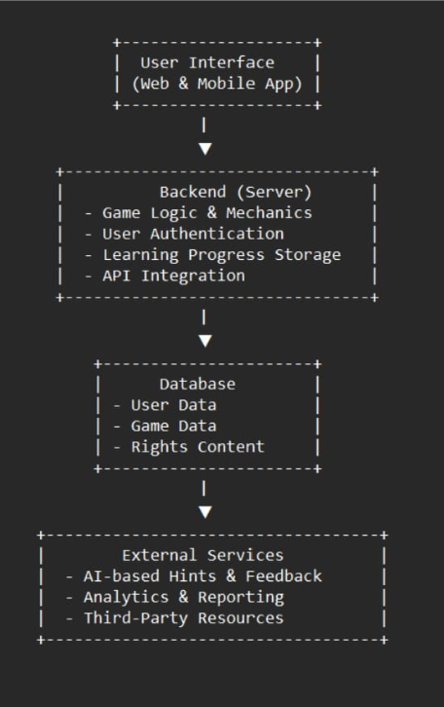
* Fig 1. System design

Table 1. **Project work mapping with SDG**

|  |  |
| --- | --- |
| **Sustainable Development Goal(SDG)** | **How it Relates to project** |
| **SDG 4:** Quality Education | Provides interactive and accessible learning to educate children about their rights. |
| **SDG 5:** Gender Equality | Promotes awareness of equal rights for boys and girls, fostering inclusivity. |
| **SDG 10:** Reduced Inequalities | Helps children from diverse backgrounds understand and advocate for their rights. |
| **SGD 16:** Peace, Justice & Strong Institution | Empowers children with knowledge to recognize and report violations. |

**CHAPTER-7**

**TIMELINE FOR EXECUTION OF PROJECT**

**(GANTT CHART)**

**Fig 2 . Gantt Chart**

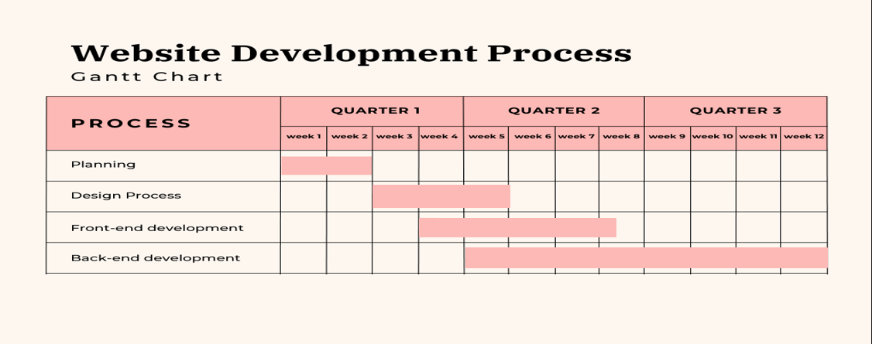

**CHAPTER-8**

**OUTCOMES**

The **Smart Education** platform is designed to create a lasting impact on children’s awareness of their rights. By integrating **gamification, interactive storytelling, and accessibility features**, the platform aims to achieve the following outcomes:

### 8.1 Educational Impact

* **Increased Legal Literacy:** Children will develop a clear understanding of their rights, including protection from child labor, abuse, and discrimination.
* **Enhanced Knowledge Retention:** Interactive and story-driven learning will improve comprehension and long-term retention of legal concepts.
* **Critical Thinking & Decision-Making Skills:** Engaging with real-life scenarios will help children develop problem-solving abilities and make informed choices in difficult situations.

### 8.2 Social & Behavioral Impact

* **Empowered Children:** The platform will encourage self-advocacy, enabling children to stand up for their own rights and those of others.
* **Improved Reporting & Help-Seeking Behavior:** By integrating direct links to child rights organizations and helplines, the platform will make it easier for children to seek assistance when needed.
* **Community Engagement:** Interactive forums and peer discussions will foster collaboration, enabling children to share knowledge and experiences.

### 8.3 Technical Outcomes

* **A Scalable & Adaptive Learning Model:** The platform will be designed to accommodate new topics, real-time updates, and expansion to broader user groups.
* **Advanced Gamification System:** Implementation of a structured reward system, leaderboard mechanisms, and personalized learning paths will enhance engagement.
* **Optimized Performance & Accessibility:** The system will incorporate lightweight design elements, ensuring smooth performance across different devices, including low-end smartphones.
* **Multilingual & Inclusive Features:** Voice assistance, text-to-speech, and regional language support will make the platform accessible to a diverse audience.
* **Data-Driven Improvements:** The platform will collect user engagement metrics and learning analytics to enhance educational effectiveness through continuous refinements.

### 8.4 Contribution to Society

* **Bridging the Knowledge Gap:** By addressing deficiencies in traditional education systems, **Smart Education** will help children from marginalized communities access crucial information.
* **A Safer Future for Children:** Increased awareness and legal literacy will contribute to reducing child exploitation, strengthening advocacy efforts, and fostering a more informed generation that actively participates in legal and social justice processes.

The **Smart Education** platform aims to revolutionize child rights education by making the learning process engaging, accessible, and impactful while leveraging technology for scalable and effective outcomes.

**CHAPTER-9**

**RESULTS AND DISCUSSIONS**

### 9.1 Evaluation of the Platform

The effectiveness of the **Smart Education** platform was assessed through **prototype testing, user feedback, and performance metrics**. The platform was evaluated based on the following criteria:

* **User Engagement:** The level of interaction and completion rates of learning modules.
* **Knowledge Retention:** Improvement in children's understanding of child rights, measured through pre- and post-assessment quizzes.
* **Accessibility & Inclusivity:** Effectiveness of multilingual support, voice assistance, and user-friendly navigation.
* **Technical Performance:** System stability, responsiveness, and compatibility across different devices.

### 9.2 User Testing & Feedback

To measure the platform’s impact, a **pilot test** was conducted with a diverse group of children (ages 8-16), educators, and child rights experts. The following observations were made:

* **Increased Participation:** Gamification elements, such as rewards and interactive challenges, led to higher engagement compared to traditional learning methods.
* **Improved Understanding:** Users demonstrated better comprehension of child rights concepts after completing the modules.
* **Ease of Use:** The intuitive design and multimedia support made it accessible to children from different backgrounds, including those with limited digital literacy.
* **Suggestions for Improvement:** Users recommended additional real-life scenarios, more regional language options, and an offline mode for children in remote areas.

### 9.3 Technical Performance

* The system performed efficiently across different devices, with **minimal latency and smooth user interactions**.
* Adaptive learning mechanisms successfully **personalized the experience**, allowing children to progress at their own pace.
* The **integration with child rights organizations** enabled direct access to legal support, making the platform more than just an educational tool.

### 9.4 Discussion on Impact & Challenges

#### **Impact on Legal Awareness**

The platform proved effective in bridging the knowledge gap in child rights education. Children showed increased confidence in identifying unsafe situations and understanding the importance of seeking help.

#### **Challenges Faced**

Despite the success, several challenges were encountered:

* **Digital Divide:** Some children, especially in rural areas, lacked access to smartphones and stable internet connections.
* **Content Localization:** Adapting the platform for different cultural and regional contexts required extensive effort.
* **User Motivation:** While gamification helped sustain engagement, maintaining long-term interest required continuous updates and new challenges.

### 9.5 Future Enhancements

Based on user feedback and observed challenges, potential improvements include:

* **Offline Accessibility:** Allowing content to be downloaded and accessed without an internet connection.
* **AI-Driven Personalization:** Further refinement of learning paths based on individual progress and interests.
* **Expanded Content Library:** Addition of more interactive stories, case studies, and expert-led discussions.

### 9.6 Summary

The **Smart Education** platform successfully demonstrated its potential to transform child rights education through **interactive and gamified learning**. While challenges remain, the system’s positive impact on engagement, comprehension, and accessibility highlights its scalability and potential for further development.

**CHAPTER-10**

**CONCLUSION**

The **Smart Education** platform represents a significant step toward transforming child rights education through an interactive and engaging approach. By leveraging **gamification, storytelling, and adaptive learning**, the platform successfully addresses the **limitations of traditional educational methods**, making complex legal concepts accessible and relatable for children aged 8-16.

Through user testing and feedback, the platform has demonstrated **high engagement levels, improved knowledge retention, and increased awareness of child rights**. The integration of **multilingual support, accessibility features, and real-world scenarios** ensures inclusivity, catering to children from diverse socio-economic and linguistic backgrounds. Furthermore, the **connection with child rights organizations** provides a crucial bridge between education and real-life assistance, empowering children to take action when needed.

While the project has yielded promising results, **challenges such as digital accessibility, content localization, and long-term engagement strategies remain areas for improvement**. Future enhancements, including **offline accessibility, AI-driven personalization, and an expanded content library**, will further strengthen the platform’s impact and reach.

In conclusion, **Smart Education** is more than just a learning tool—it is an initiative to **empower children, bridge the gap in legal literacy, and foster a society where young individuals are aware of their rights and capable of standing up for themselves and others**. By continuously refining and expanding this platform, we can create a lasting impact, ensuring that every child in India has the knowledge and confidence to navigate their legal rights effectively

**REFERENCES**

•**Kahoot! Online Rights Games** – Interactive quizzes teaching children about their rights.  
 <https://www.unicef.org.uk/rights-respecting-schools/the-rights-runner-game/>

•**UNICEF's Right Runner Game** – A mobile game raising awareness on children's rights.  
 <https://www.unicef.org/press-releases/right-runner-game>

•**Gamified Learning for Legal Education** – Research on gamification for teaching complex topics.  
 <https://jetir.org/papers/JETIR2201124.pdf>

•**Human Rights Game** – Educational game to teach legal rights and prevent bullying.  
 [https://www.humanrightsgame.com](https://www.humanrightsgame.com/)

•**Teaching Expertise: Children's Rights Activities** – Educational tools for schools.  
 <https://www.teachingexpertise.com/classroom-ideas/childrens-rights-activities>

**APPENDIX-A**

**PSUEDOCODE**

**Fig 3. Private Route.js**

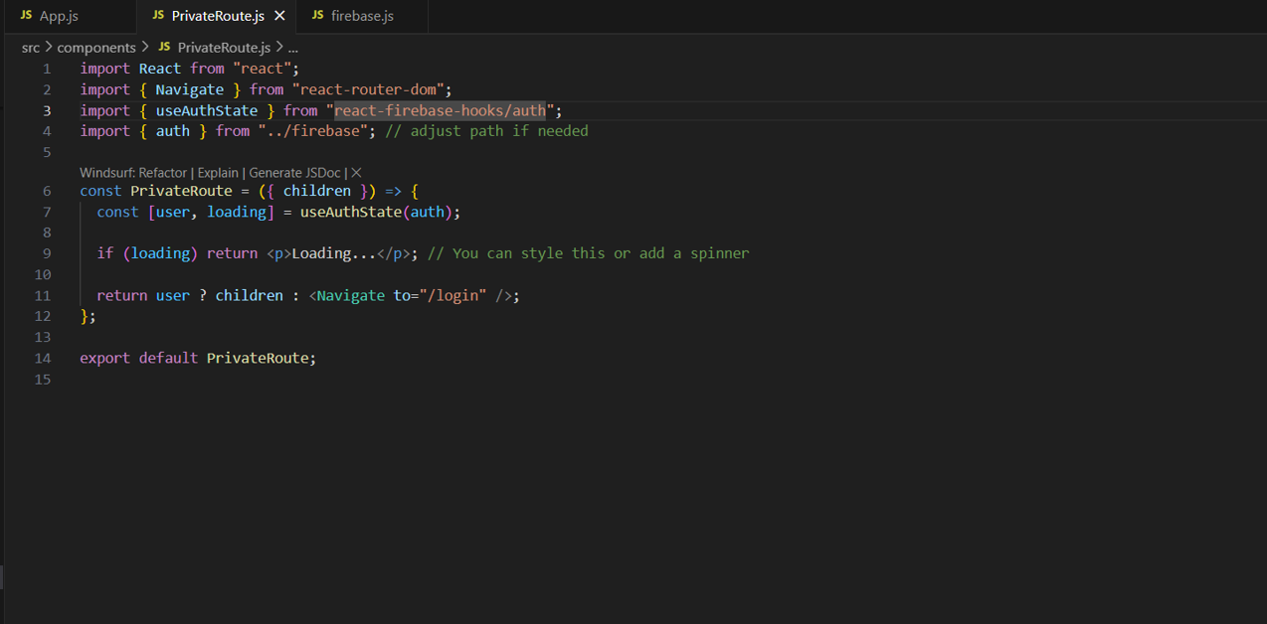

**Fig 4. Firebase . Js**

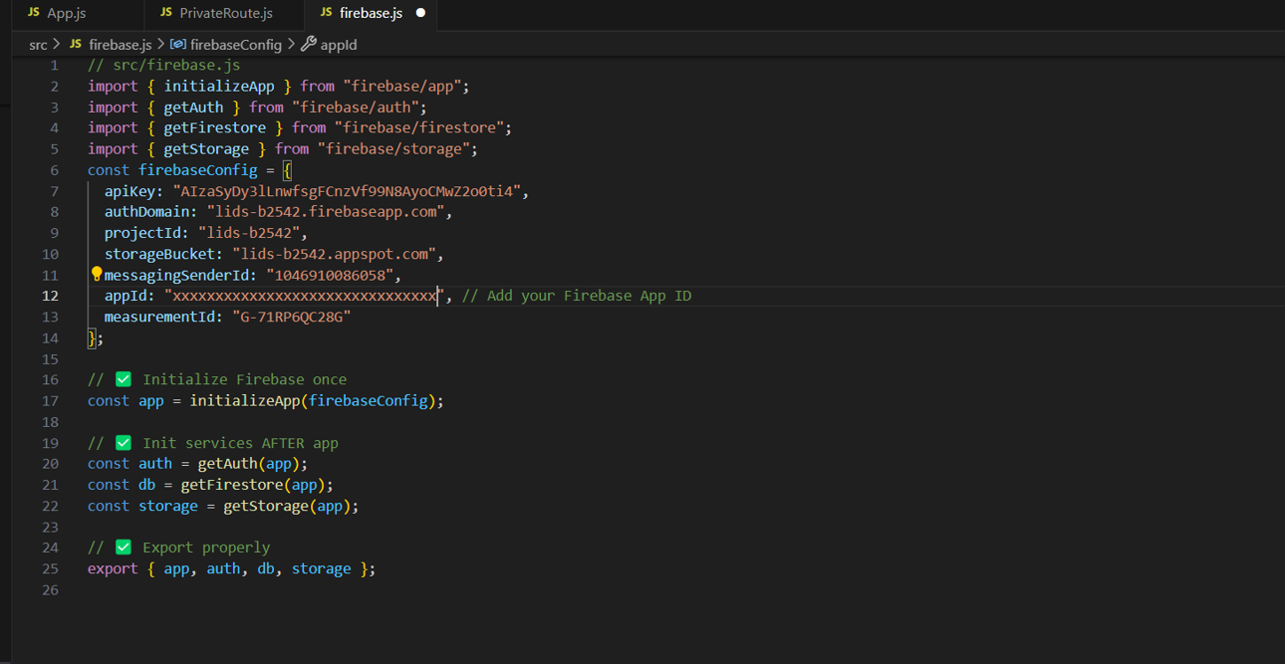

**Fig 5.Logo**

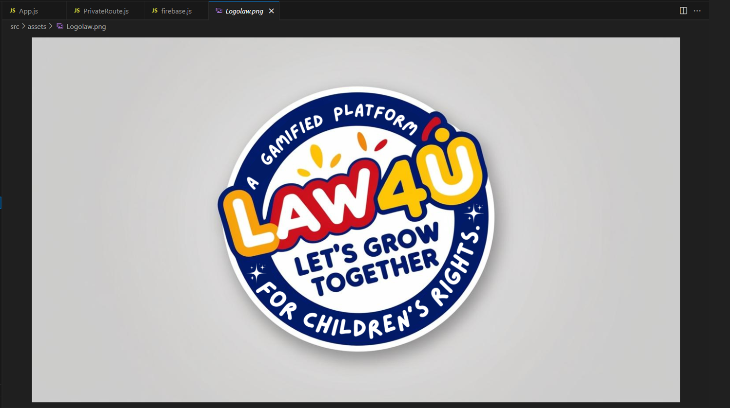

**Fig 6. App.js**

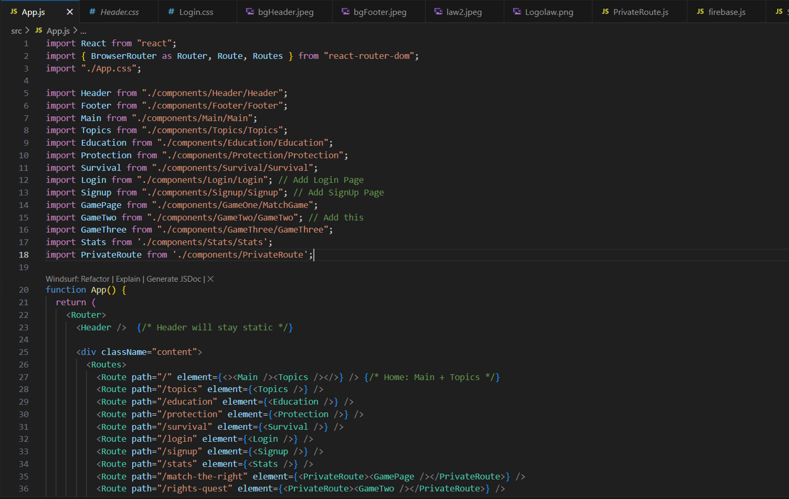

**Fig 7. App.js**

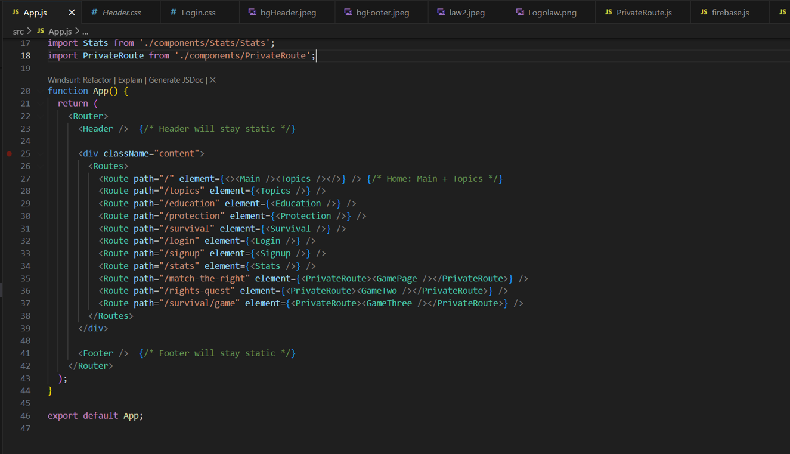

**APPENDIX-B**

**SCREENSHOTS**

**Fig 8. Sign up page**



**Fig 9. Login page**



**Fig 10. Header**



**Fig 11. Platform Features**



**Fig 12. Home page**

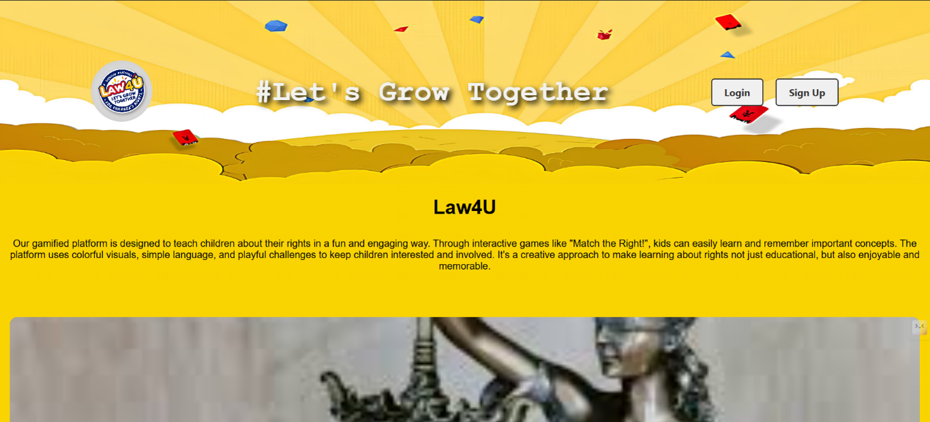

**Fig 13. Key features**

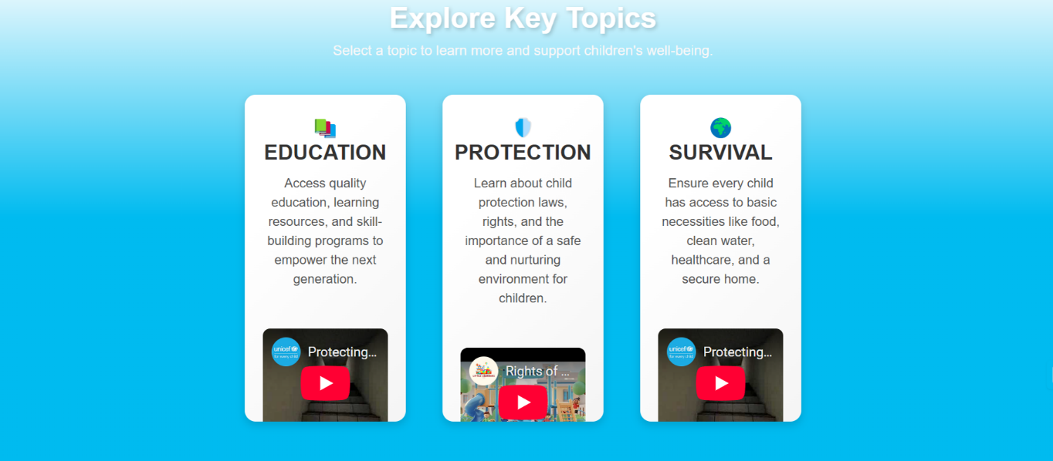

**Fig 14. Quiz game(Protection)**

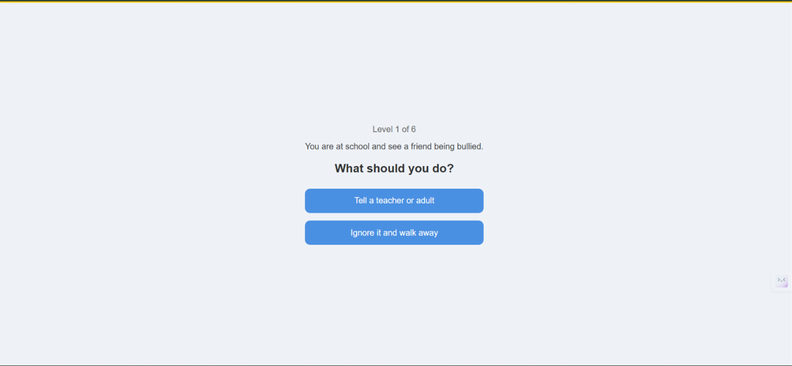

**Fig 15. Card Game**

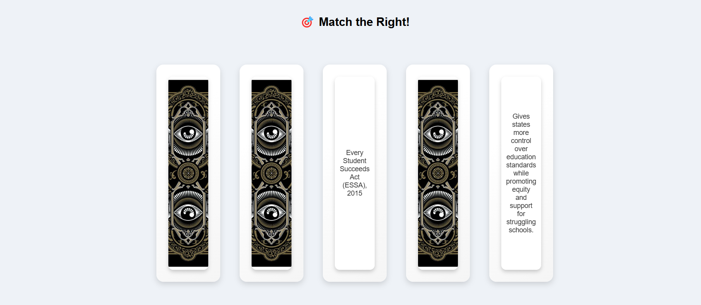

**Fig 16. Card game**

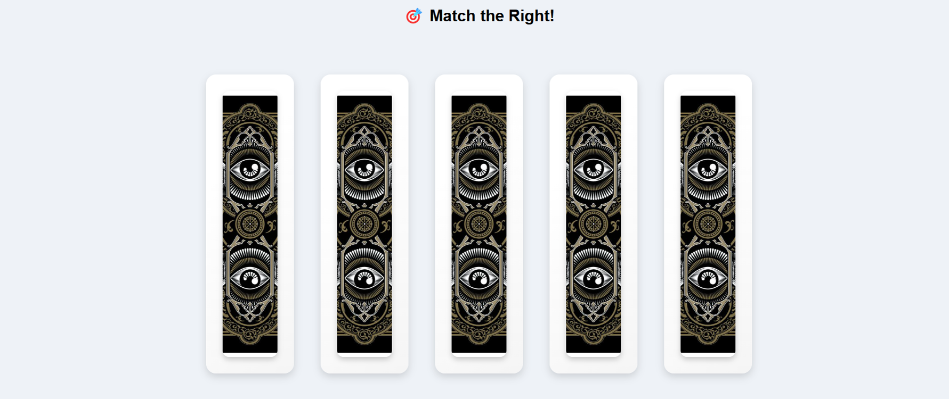

**Fig 17. YouTube Video Page**

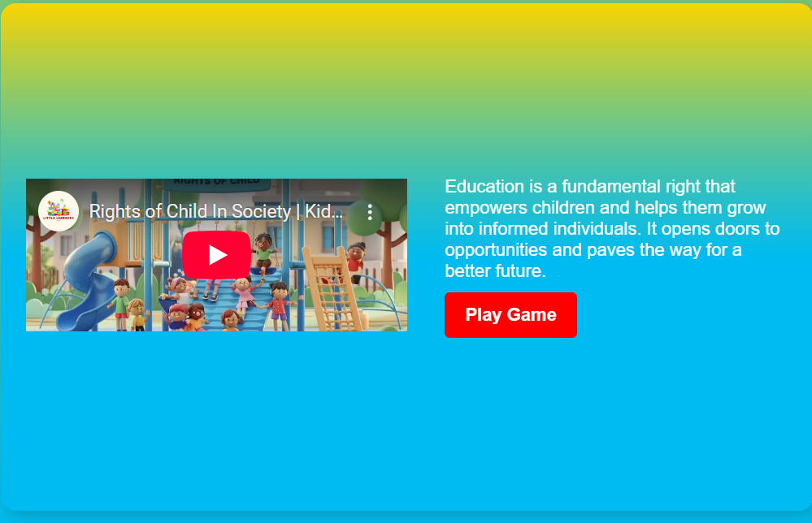

**Fig 18. Drag and drop game**

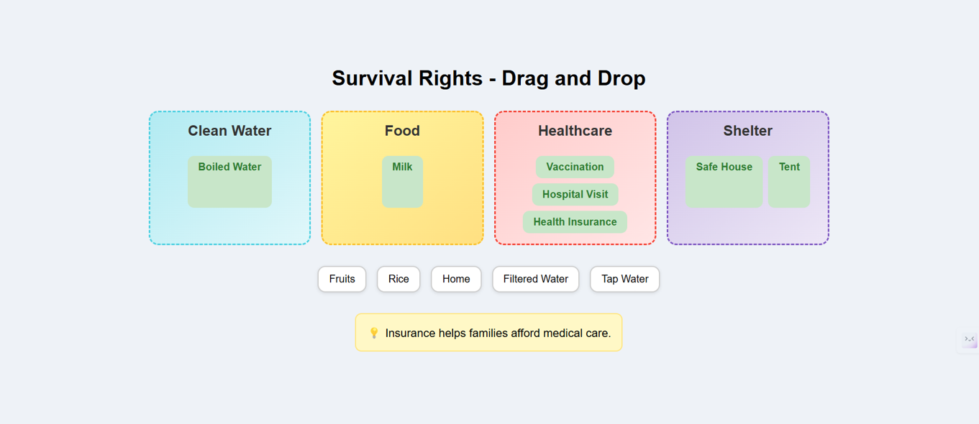

**Fig 19. Completion Certificate**

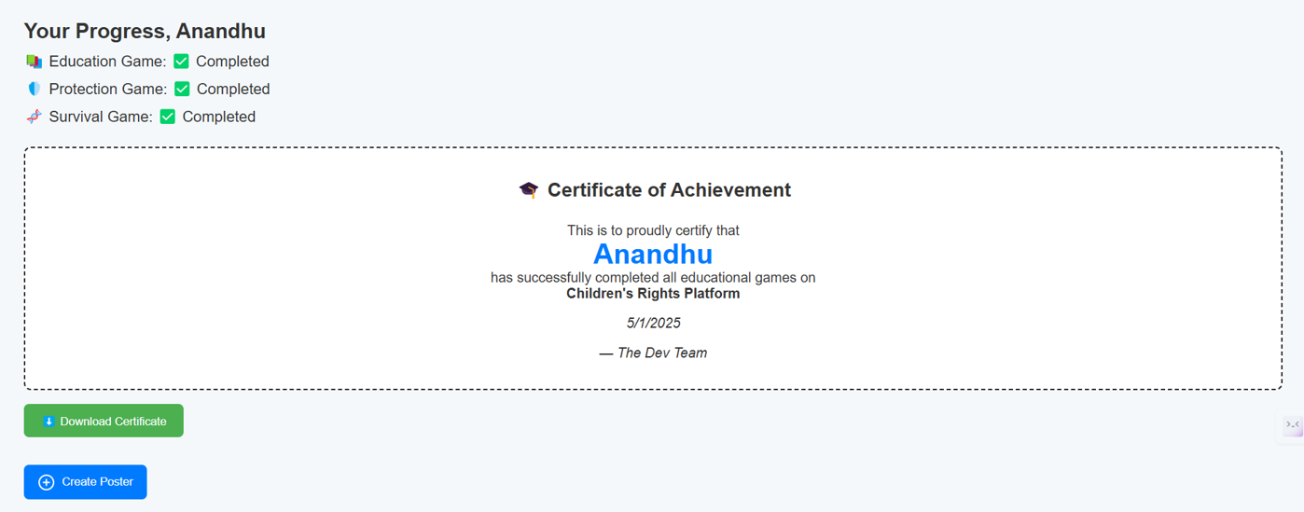

**Fig 20. Footer**

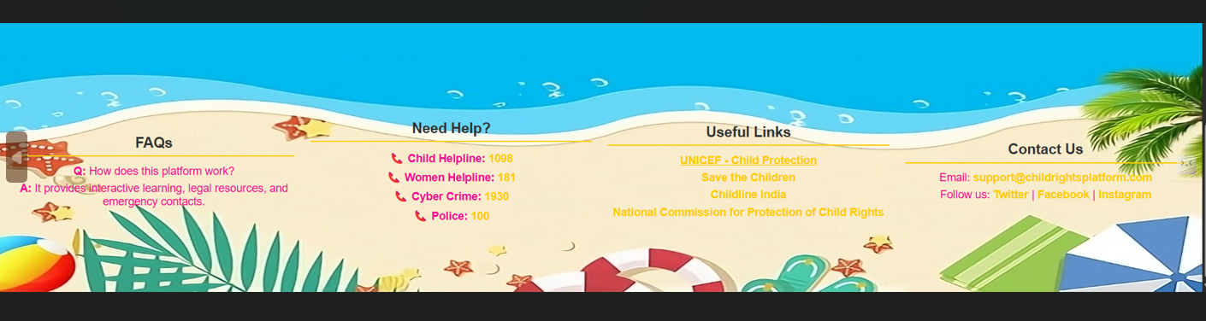

**APPENDIX-C**

**ENCLOSURES**

**1. Journal publication/Conference Paper Presented Certificates of all students.**

**2. Include certificate(s) of any Achievement/Award won in any project-related event.**

**3. Similarity Index / Plagiarism Check report clearly showing the Percentage (%). No need for a page-wise explanation.**

**4.** **Details of mapping the project with the Sustainable Development Goals (SDGs).**